**A) Import project in Android Studio**- [top](https://doc.willdev.in/SAM_VPN/#toc)

• Open Android Studio and Open Existing Project.

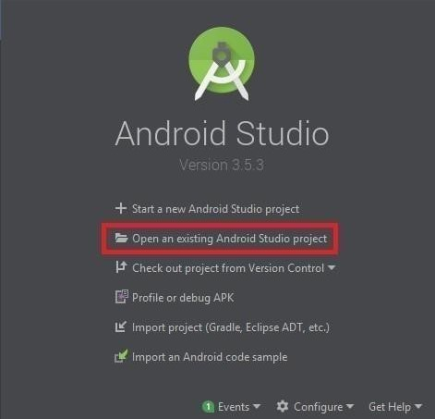

• Select your Project File (Source code).

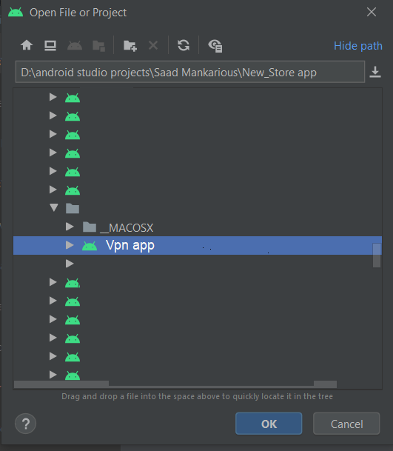

**B) Change package name**- [top](https://doc.willdev.in/SAM_VPN/#toc)

For example, if you want to change com.example.app to Com.awesome.appthen:

1.In your Project pane, click on the little gear icon.

2.Uncheck / De-select the Compact Empty Middle Packagesoption

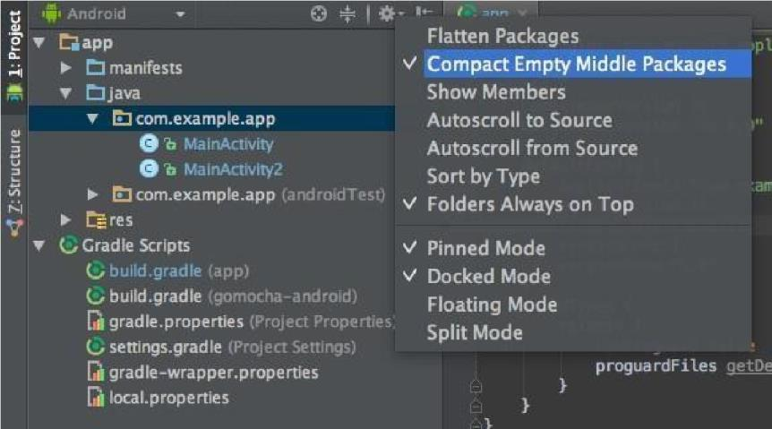

3. Your package directory will now be broken up in individual directories

4. Individually select each directory you want to rename, and:

* Right-click it
* Select Refactor
* Click on Rename
* In the Pop-up dialog, click on Rename Package instead of Rename Directory
* Enter the new name and hit **Refactor**
* Click **Do Refactor** in the bottom
* Allow a minute to let Android Studio update all changes
* *Note: When renaming com in Android Studio, it might give a warning. In such case, select* **Rename** **All**

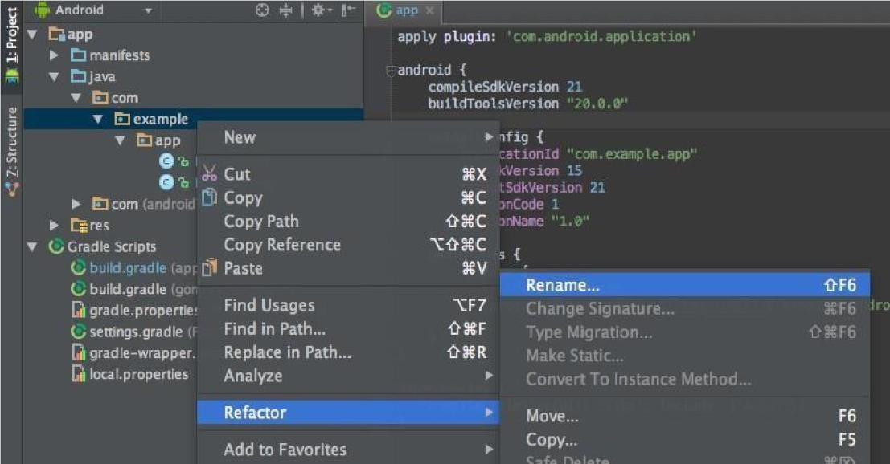

1. Now open your ***Gradle Build File*** (build.gradle - Usually app or mobile). Update the applicationId in the defaultConfig to your new Package Name and Sync Gradle, if it hasn't already been updated automatically:

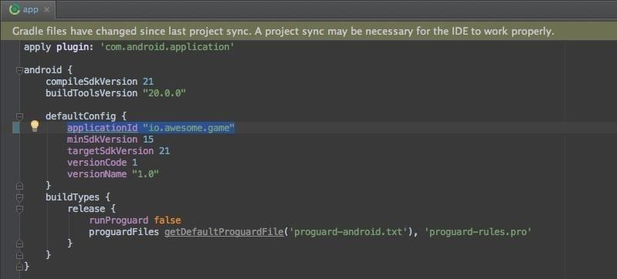

1. You may need to change the package= attribute in your manifest.
2. Clean and Rebuild.

**C) Change app Name** - [top](https://doc.willdev.in/SAM_VPN/#toc)

   For Change App Name Go > app > res > value > string.xml

                     <string name="app_name">**YOUR APP NAME**</string>

**D) Change app icon**- [top](https://doc.willdev.in/SAM_VPN/#toc)

* For Change App Icon Go > app > res > drawable > logo.png
* For Change Splash icon Go > res > drawablde logo.png
* Keep your icon name rocket.png and paste in drawable folder then show popup click on overwrite option.

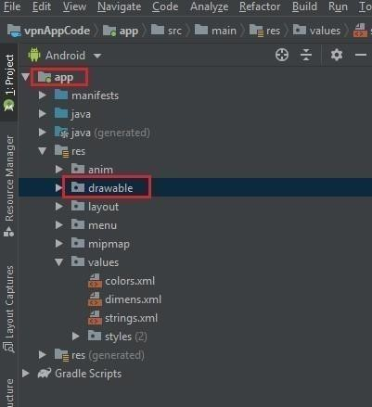

**E) Change Admob Ads I’d**- [top](https://doc.willdev.in/SAM_VPN/#toc)

        For Change Ads I’d Go > firebase > Ads

**F) Setup Firebase Configuration.**- [top](https://doc.willdev.in/SAM_VPN/#toc)

**At the**[**https://firebase.google.com/**](https://firebase.google.com/)**link click to the “Go to console” button.**

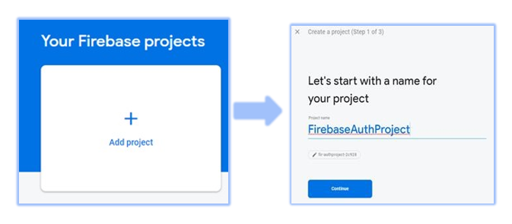

After That, Put your project name here. And Select your Country here. And Click on Create Project.

And After that, Go to Project Setting, And select Android Project.

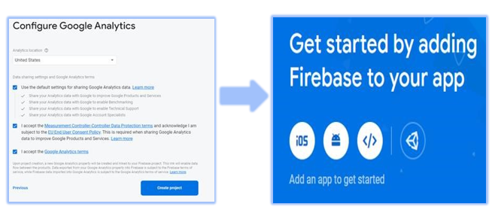

After that, Put your Package name and click on Register app.

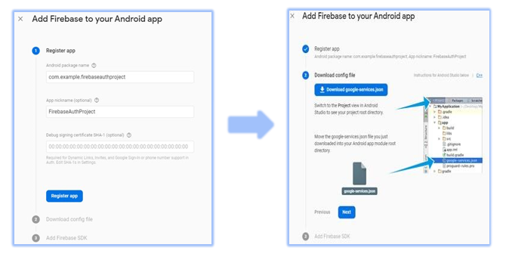

After that, Download google-service.json file and paste it in in inside the project.

**G) Setup In-App-Subscription.**- [top](https://doc.willdev.in/SAM_VPN/#toc)

Go to You Google Play Console >  monetization-setup  > After that Copy the base64 Key

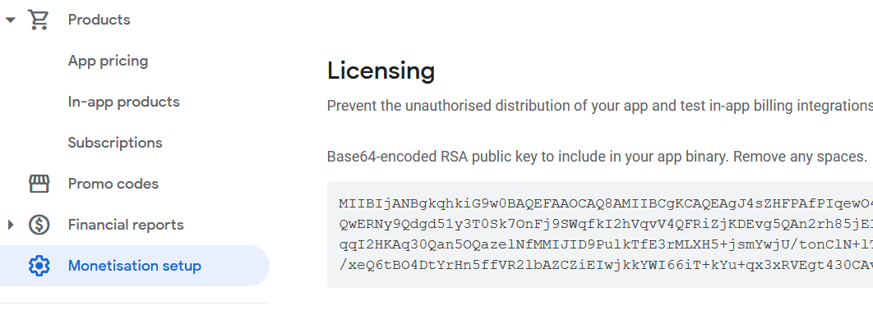

After that Go to Config > and Paste your Base 64 Key on key place.

After that Go to Products and Create Your Subscription and after that Go to Config and Put the Subscription I'd

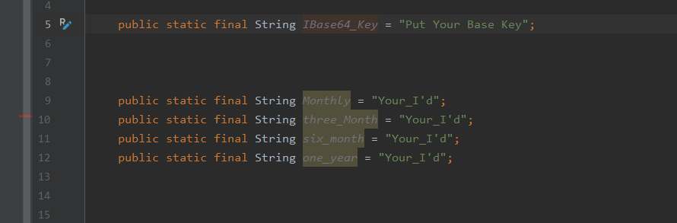

Once again, thank you so much for purchasing this theme. As I said at the beginning, I'd be glad to help you if you have any questions relating to this theme. No guarantees, but I'll do my best to assist. If you have a more general question relating to the themes on ThemeForest, you might consider visiting the forums and asking your question in the "Item Discussion" section.